HANOI UNIVERSITY
FACULTY OF INFORMATION
TECHNOLOGY



FINAL REPORT

Frequent Co-occurrence Pattern Analysis of
Retinal Pathologies on the ODIR-5K Dataset

Module Name: Big Data Mining
Lecturer: Bui Quoc KhanH
Group: 16 Class: BDM_CLC03
Members: Vu Anh Dung 2201140020
Do Tuan Dung 2201140018
Nguyen Cong Quoc Khanh
2201140044

Contents
1. Introduction 4
1.1. Background and Motivation 4
1.2. Problem Statement and Research Gap 4
1.3. Objectives and Contributions 5
1.4. Document Structure 5
2. Related Work 6
2.1. Deep Learning–based Approaches for the ODIR-5K Dataset 6
2.2. Association Rule Mining (ARM) in Medical Informatics 6
2.3. Research Gap 7
3. Data and preprocessing 8
`3.1. Dataset Description 8
3.2. Data Cleaning and Preparation 11
3.2.2. Categorical Encoding 11
3.2.3. Pathological Label Mapping 11
3.3. Transactional Data Transformation 11
3.4. Data Characteristics and Sparsity: 12
4. Methodology 12
4.1. Problem Formulation 12
4.2. Transaction Modeling Strategy 12
4.3. Frequent Pattern Mining 13
4.4. Association Rule Generation 13
4.5. Rule Filtering Strategy 14
4.6. Demographic-aware Subgroup Analysis 14
4.7. Analytical Framework for Rule Interpretation 15
5. Experiments and Results 15
5.1. Experimental Setup 15
5.2. Overview of Extracted Rules 16
5.3. Key Association Patterns 16
5.3.1. Age-related patterns in Cataract 16
5.3.2. Demographic patterns in systemic diseases 17
5.3.3. Less informative patterns 18
5.4. Interpretation of Rule Strength 18
5.5. Summary of Findings 19
6. Discussion and Conclusion 19
6.1. Discussion 19
6.1.1. Consistency with Clinical Knowledge 19
6.1.2. Demographic Patterns in Chronic Diseases 20
6.1.3. Interpretability Compared to Deep Learning Approaches 20
6.1.4. Limitations of the Study 20
6.2. Conclusion 21
6.3. Future Work 21
Preferences 23

Frequent Co-occurrence Pattern Analysis of
Retinal Pathologies on the ODIR-5K Dataset

1. Introduction

1.1. Background and Motivation
Rapid epidemiological shifts in Asian populations, characterized by urbanization and lifestyle changes, have led to a significant increase in noncommunicable chronic diseases, most notably diabetes and hypertension. These systemic diseases are major contributors to secondary ocular complications, including diabetic retinopathy (DR), glaucoma, and hypertensive retinopathy. In clinical practice, these diseases rarely occur individually; instead, they often coexist in the same patient.
Large-scale community screening is essential to prevent irreversible vision loss. However, effective screening requires more than just high accuracy in detection; it demands a deep understanding of the correlations between demographic factors such as age and sex with specific disease groups. Identifying these patterns can provide clinicians and public health officials with useful insights for targeted intervention strategies.

1.2. Problem Statement and Research Gap
The Ocular Disease Intelligent Recognition (ODIR-5K) dataset has become a benchmark for evaluating automated diagnostic systems. To date, the vast majority of research utilizing this dataset has focused on Deep Learning (DL) architectures, specifically Convolutional Neural Networks (CNNs), to achieve high classification accuracy from fundus images.
Despite their performance, these "black-box" models suffer from two critical limitations:
- Lack of Interpretability: They provide little to no explanation regarding the underlying relationships between clinical labels and patient demographics.
- Label Independence: Most DL approaches treat diagnostic labels as independent variables, failing to capture the rich, hidden associations between co-occurring ocular diseases.
There is a significant research gap in applying explainable Data Mining (DM) techniques to the structured diagnostic data of ODIR-5K. Specifically, the use of Association Rule Mining (ARM) to uncover how demographic attributes influence multi-label disease combinations remains largely underexplored.

1.3. Objectives and Contributions
To address these gaps, this study shifts the focus from image classification to pattern discovery within structured medical records. The primary objective is to apply the FP-Growth (Frequent Pattern Growth) algorithm to extract meaningful association rules from 6,392 patient records.
The specific objectives are:
- To transform multi-label diagnostic data and demographic attributes (Age, Gender) into a transactional format suitable for association mining.
- To identify frequent co-occurrence patterns of ocular diseases across different demographic subgroups.
- To evaluate the strength and reliability of these relationships using Support, Confidence, and Lift metrics.
The main contributions of this work include:
- Providing a transparent and interpretable alternative to traditional Deep Learning models for the ODIR-5K dataset.
- Uncovering clinically relevant patterns that highlight the influence of aging and gender on disease clusters.
- Developing a framework that supports community-level eye screening strategies by identifying high-risk profiles based on demographic and diagnostic history.

1.4. Document Structure
The remainder of this study is organized as follows: Section 2 reviews the existing literature on ODIR-5K and data mining in healthcare. Section 3 details the methodology, including data preprocessing and the FP-Growth algorithm. Section 4 presents the experimental results and extracted rules. Finally, Section 5 discusses the clinical implications, limitations, and concludes the study with directions for future work.

2. Related Work

2.1. Deep Learning–based Approaches for the ODIR-5K Dataset
Since its release by Peking University, the ODIR-5K dataset has become a primary benchmark for medical computer vision research.

Recent studies have extensively applied deep learning techniques, particularly Convolutional Neural Networks (CNNs), for automated ocular disease classification on the ODIR-5K dataset. Several IEEE-based works have demonstrated the effectiveness of CNN architectures in classifying retinal diseases from fundus images, achieving strong performance in terms of Accuracy and F1score [1], [2].
Beyond conventional single-label classification, recent research has also explored multi-label learning frameworks to better reflect real-world clinical scenarios. For instance, a study in [3] proposes a multi-label classification approach using K-fold cross-validation on the ODIR-5K dataset, highlighting the feasibility of detecting multiple co-occurring diseases within a unified framework.
In addition, more advanced deep learning strategies have been introduced to improve model robustness and performance. For example, transfer learning combined with model fusion techniques has been shown to enhance classification accuracy and generalization capability in ocular disease recognition tasks[pmc]. These approaches typically leverage pre-trained architectures such as ResNet and incorporate feature fusion mechanisms to address data imbalance and improve predictive reliability.
Furthermore, emerging preprint studies available on platforms such as TechRxiv continue to explore novel deep learning architectures for fundus image analysis, reflecting the ongoing research interest in this domain.
However, despite these advancements, most existing approaches remain focused on optimizing predictive performance at the image level. They often treat each eye independently and do not explicitly model the relationships among co-occurring disease labels or integrate structured demographic information, such as age and gender.

2.2. Association Rule Mining (ARM) in Medical Informatics
Data Mining (DM), particularly Association Rule Mining (ARM), has demonstrated effectiveness in supporting clinical decision-making.
Association Rule Mining (ARM) has been widely applied in medical informatics to uncover hidden relationships within structured clinical data, particularly for identifying co-occurrence patterns among diseases. Several studies have demonstrated the effectiveness of ARM techniques, such as the FP-Growth algorithm, in analyzing patient records and discovering meaningful associations between diagnoses.
For example, prior research has applied FP-Growth to hospital datasets encoded with ICD-10 codes to identify inter-disease relationships, revealing frequent cooccurrence patterns among chronic conditions[5] . Similarly, ARM has been used to analyze disease complications, enabling the discovery of relationships between primary conditions and their associated comorbidities[6] . These approaches highlight the capability of ARM to model multi-label clinical scenarios, where multiple diseases may coexist within a single patient.
Beyond disease analysis, ARM has also been employed in clinical decision support systems to extract associations between symptoms, diagnostic tests, and medical outcomes, thereby assisting physicians in understanding complex clinical relationships[2706] . Additional applications include drug-related analysis, such as identifying patterns in medication usage and detecting potential adverse effects, further demonstrating the versatility of ARM in healthcare domains[8] .
Despite these advantages, the application of ARM in ophthalmology remains relatively limited. In particular, few studies have explored the use of ARM for analyzing multi-label ocular disease datasets in conjunction with demographic attributes such as age and gender. This gap highlights the need for interpretable data-driven approaches capable of uncovering complex co-occurrence patterns in large-scale datasets such as ODIR-5K.

2.3. Research Gap
Despite the rapid advancement of deep learning techniques for ocular disease classification on the ODIR-5K dataset, most existing approaches primarily focus on improving predictive performance from fundus images. These models typically operate as black-box systems and assume independence among diagnostic labels, thereby failing to capture the complex relationships between co-occurring ocular diseases and patient-specific factors.
On the other hand, Association Rule Mining (ARM) has demonstrated strong potential in medical informatics for uncovering interpretable relationships among clinical variables. However, its application in ophthalmology remains limited, particularly in the context of large-scale, multi-label datasets. Existing ARM-based studies in healthcare often rely on relatively small datasets or non-standardized data sources, and rarely incorporate both diagnostic and demographic attributes in a unified analytical framework.
Therefore, there exists a clear research gap in applying interpretable data mining techniques to structured ophthalmic datasets such as ODIR-5K. Specifically, the use of ARM to analyze the co-occurrence patterns of ocular diseases while simultaneously considering demographic factors (e.g., age and gender) remains underexplored.
To address this gap, this study applies the FP-Growth algorithm to a large-scale dataset of 6,392 patient records, transforming multi-label diagnostic and demographic data into a transactional format. By extracting association rules based on Support, Confidence, and Lift, the proposed approach provides a transparent and clinically interpretable framework for understanding disease patterns, offering new insights for epidemiological analysis and community-level screening strategies.

3. Data and preprocessing

3.1. Dataset Description
This study utilizes the ODIR-5K dataset, which contains 6,392 patient records. Each record originally includes 19 attributes, comprising both retinal images and structured clinical data.
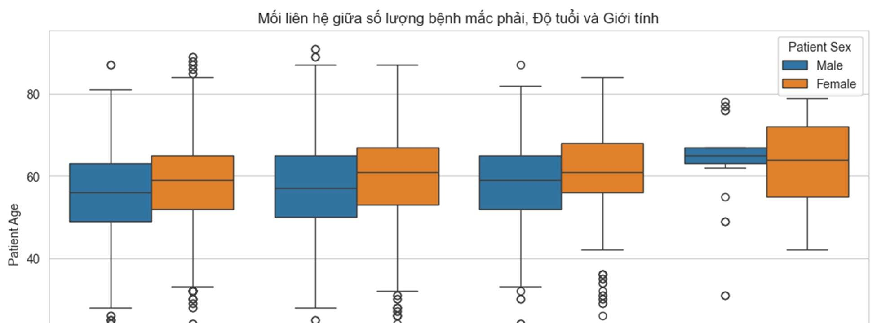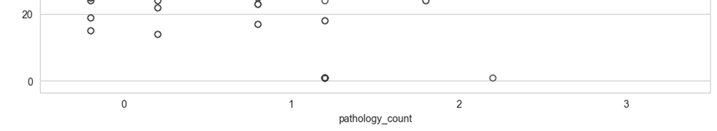

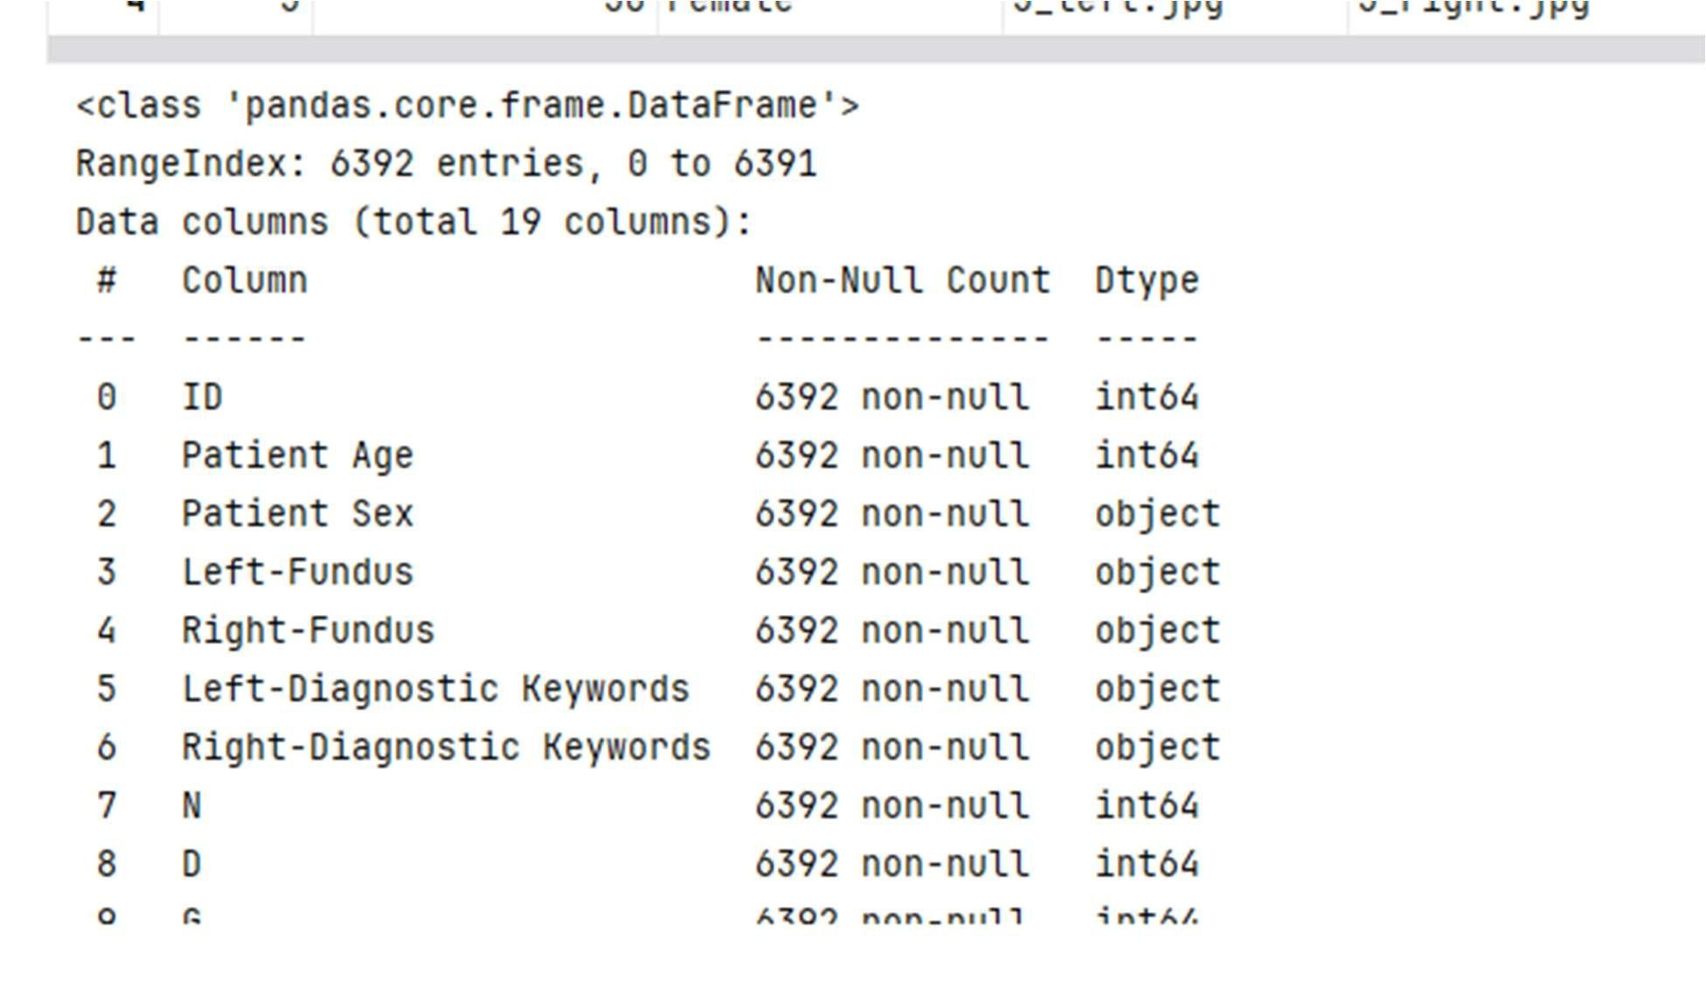
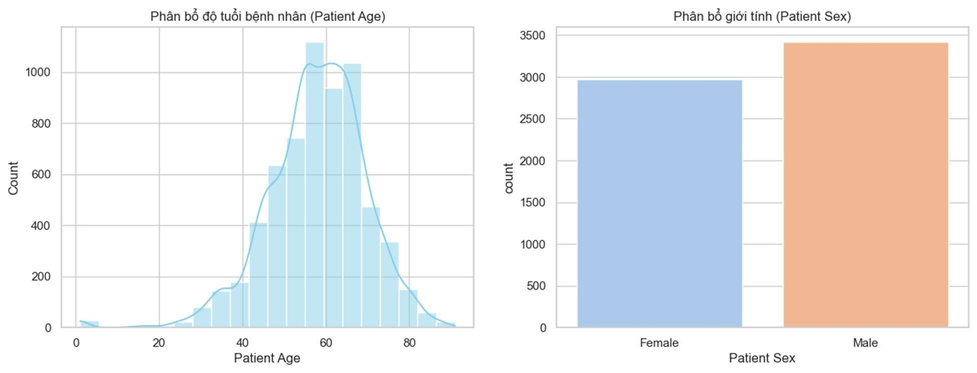

To facilitate association rule mining, only a subset of relevant structured attributes was retained. These include:
- Demographic variables: Patient Age and Patient Sex
- Diagnostic labels: eight binary indicators (N, D, G, C, A, H, M, O), corresponding to Normal, Diabetes, Glaucoma, Cataract, Age-related
Macular Degeneration (AMD), Hypertension, Myopia, and Other diseases
- 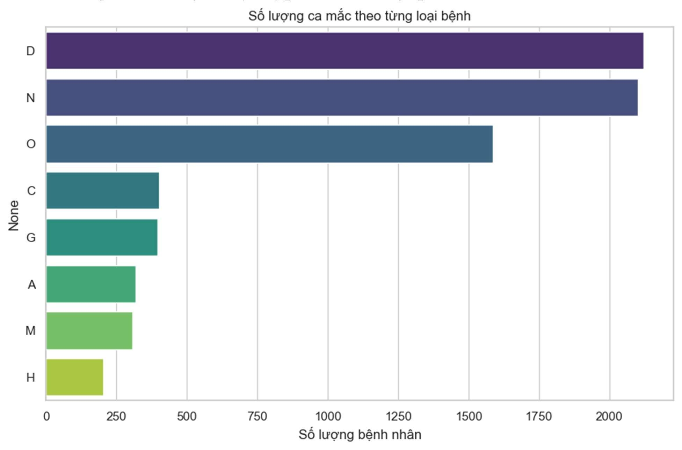
Attributes related to image data (e.g., Left-Fundus, Right-Fundus, file paths), identifiers (ID), and textual diagnostic keywords were excluded to reduce noise and focus on structured clinical relationships.

3.2. Data Cleaning and Preparation

To prepare the dataset for association rule mining, several preprocessing steps were applied to ensure consistency and compatibility with transactional data representation.
3.2.1. Age Discretization:
Because the FP-Growth algorithm only processes nominal data, the continuous numerical attribute Patient Age is converted into categorical variables. We perform age grouping based on common clinical thresholds in ophthalmology: Age_Young: < 40 years old. Age_Middle: 40 – 60 years old. Age_Old: > 60 years old (High-risk group for degenerative eye diseases).

3.2.2. Categorical Encoding

The Patient Sex attribute is normalized to specific labels (Gender_Male, Gender_Female) to ensure uniqueness and avoid confusion with numerical values during rule mining.

3.2.3. Pathological Label Mapping

The disease labels (D, G, C, A, H, M, O) are currently in binary format (0 or 1). We convert these values to the corresponding disease name if the value equals 1. In this study, the label Normal (N) can be removed when analyzing co-occurring disease sets to focus on complex pathological relationships.

3.3. Transactional Data Transformation
After preprocessing, each patient record is transformed into a "Transaction" — a list of items containing demographic information and the types of diseases that the patient has. Example of the transformed data structure:
$Patient_\{i\} = \{Age_Old, Gender_Female, Diabetes, Hypertension\}$
This format allows the FP-Growth algorithm to build an efficient FP-Tree structure, compressing data and extracting frequent sets without traversing the dataset multiple times.

3.4. Data Characteristics and Sparsity:
The processed data has the following characteristics: Multi-label: A patient may have multiple disease labels simultaneously, which is a prerequisite for finding association rules. Sparsity: The majority of patients only have one or two diseases, leading to a sparse data matrix. FP-Growth was chosen over Apriori because of its better ability to handle sparse data and faster execution speed on datasets > 6,000 records.

4. Methodology

4.1. Problem Formulation
Let the preprocessed dataset be represented as a set of transactions: D = {T₁, T₂, ..., Tₙ}
where each transaction Tᵢ ⊆ I contains a set of items representing demographic attributes and diagnostic labels.
The goal is to discover association rules of the form: X → Y, where X ∩ Y = ∅
which reveal co-occurrence relationships among ocular diseases and their associations with demographic factors. This formulation follows the standard framework of Association Rule Mining (ARM) [1].

4.2. Transaction Modeling Strategy
To enable association rule mining, each patient record is modeled as a transaction that integrates both demographic information and diagnostic labels. This unified representation allows the analysis to capture:
- Disease–disease relationships (e.g., co-occurring conditions)
- Demographic–disease relationships (e.g., age or gender as risk factors)
Unlike conventional approaches that analyze diseases independently, this modeling strategy provides a more comprehensive view of patient-level clinical patterns.
Frequent itemsets are extracted using the FP-Growth algorithm, which efficiently mines frequent patterns without candidate generation [3].
An itemset X is considered frequent if: Support(X) ≥ min_sup where support is defined as the proportion of transactions containing X [1].
A moderate minimum support threshold (e.g., 0.05) is adopted, following common practices in association rule mining applications in healthcare [4].

4.3. Frequent Pattern Mining
Frequent itemsets are extracted using the FP-Growth algorithm proposed by Jiawei Han et al. [4], which eliminates candidate generation and improves efficiency compared to Apriori-based methods.
An itemset X is considered frequent if:
$Support(X) = |\{Tᵢ ∈ D : X ⊆ Tᵢ\}| / |D| ≥ min_sup$
A minimum support threshold of 0.05 is adopted in this study. This choice is consistent with prior applications of ARM in healthcare datasets, where moderate thresholds are used to balance pattern significance and data sparsity [5].
Medical datasets are typically sparse due to the relatively low co-occurrence frequency of multiple diseases, making overly high support thresholds impractical.

4.4. Association Rule Generation
From the frequent itemsets, association rules are generated and evaluated using standard ARM metrics [1]:
- Support
- Confidence
- Lift
$Confidence(X → Y) = Support(X ∪ Y) / Support(X)$
$Lift(X → Y) = Confidence(X → Y) / Support(Y)$
Among these, lift is particularly important as it measures the strength of association beyond random co-occurrence. A lift value greater than 1 indicates a positive correlation between itemsets.

4.5. Rule Filtering Strategy
To ensure reliability and interpretability, the following thresholds are applied:
- Support ≥ 0.05
- Confidence ≥ 0.55
- Lift > 1.2
The confidence threshold is selected based on prior studies in clinical ARM applications, where moderate-to-high confidence values are used to ensure rule reliability [5].
Additionally, preliminary experiments conducted in this study indicate that:
- Lower thresholds produce a large number of noisy and insignificant rules
- Higher thresholds eliminate meaningful but less frequent co-occurrence patterns
Therefore, the selected thresholds provide a balance between interpretability and coverage, which is critical in exploratory medical data analysis.

4.6. Demographic-aware Subgroup Analysis
To capture variations across different population groups, the dataset is partitioned into subgroups based on demographic attributes:
- Gender-based groups: Male, Female
- Age-based groups: Young, Middle, Old
Association rule mining is then performed independently on each subgroup. This enables the identification of group-specific patterns that may not be observable in the global dataset.

4.7. Analytical Framework for Rule Interpretation
The extracted rules are further categorized into two main types:
- Disease–Disease Rules: capturing co-occurrence patterns among ocular diseases
- Demographic–Disease Rules: identifying potential risk factors associated with specific patient groups
This classification facilitates a structured interpretation of results, supporting both clinical understanding and epidemiological analysis.

5. Experiments and Results

5.1. Experimental Setup
This study utilizes the Python programming language along with the mlxtend library to implement the FP-Growth algorithm. FP-Growth was selected for its efficiency in handling sparse healthcare datasets without the need for explicit candidate generation. To extract statistically significant and clinically relevant patterns, the following thresholds were empirically established [5]:
- Minimum Support: 0.05.
- Minimum Confidence: 0.55.
- Minimum Lift: 1.20.

5.2. Data Preprocessing and Transaction Modeling
The ODIR-5K dataset, containing 6,392 patient records, underwent a transformation process to fit the transactional format required by ARM.
- Age Discretization: The continuous "Patient Age" variable was binned into three primary groups: Young (<40), Middle-aged (40–60), and Old (>60).
- Encoding: Categorical variables were converted into a binary matrix using one-hot encoding.
- Filtering: Only records containing at least one diagnostic label were retained, resulting in 4,291 transactions used for the mining process.

5.3. Exploratory Data Analysis (EDA) Insights
Initial analysis of the dataset revealed several key trends:
- Age Distribution: The majority of patients fall within the middle-aged to elderly categories (50–70 years old), which aligns with the prevalence of age-related conditions like Cataract and AMD.
- Disease Prevalence: Diabetes (D) is the most frequent pathological label in the dataset.
- Multi-morbidity: Over 1,000 patients were diagnosed with two or more conditions simultaneously, highlighting the necessity of co-occurrence analysis.

5.4. Key Association Patterns
The FP-Growth algorithm successfully identified several meaningful demographic–disease relationships. The top rules, ranked by their lift values, are presented below:

Rank | Antecedents | Consequents | Support | Confidence | Lift
1 | Cataract | Age_Old | 696 | 7.437 | 1.5026
2 | Glaucoma | Age_Old | 601 | 6.498 | 1.3129
3 | Diabetes, Gender_Male | Age_Middle | 1.617 | 5.866 | 1.3043
4 | {Gender_Male, Age_Middle | Diabetes | 1.617 | 6.077 | 1.2282
5 | Cataract | Gender_Female | 545 | 5.820 | 1.2237
6 | Age_Middle | Diabetes | 2.677 | 5.953 | 1.2032

Table 5.1: Top Association Rules Extracted from ODIR-5K

5.5. Interpretation and Discussion

5.5.1. Aging as a Primary Risk Factor
The strongest rule discovered is the association between Cataract and Old Age, with a confidence of 74.37% and a lift of 1.50. This provides empirical evidence from the ODIR-5K dataset that patients over 60 are significantly more likely to develop cataracts compared to other age groups. Similarly, Glaucoma shows a strong tie to the Age_Old group (Confidence: 64.98%), reinforcing aging as the dominant factor for degenerative ocular diseases.

5.5.2. Systemic Disease and Demographic Clusters
The model identified a significant risk cluster for Diabetes within the Middle-aged and Male population. The rule Age_Middle -> Diabetes showed a high support of 0.2677 and a confidence of 59.53%. When gender is factored in, the rule Gender_Male, Age_Middle -> Diabetes maintains a high confidence of 60.77%. This suggests that middle-aged men represent a high-risk demographic for systemic conditions that eventually lead to diabetic retinopathy.

5.5.3. Gender-Specific Findings

Cataract prevalence shows a positive association with the Female gender (Lift: 1.22, Confidence: 58.20%). While aging is the primary driver, this rule suggests a slightly higher likelihood for female patients to be diagnosed with cataracts within this specific dataset compared to the general population baseline.

5.6. Conclusion on Rule Interpretability
The results demonstrate that Association Rule Mining provides a transparent framework for understanding medical data. Unlike "black-box" neural networks, these rules quantify specific risks (e.g., a 74% probability of being elderly if diagnosed with cataracts), offering actionable insights for community-based screening and early intervention strategies.

6. Discussion and Conclusion

6.1. Discussion
This study utilizes Association Rule Mining (ARM) to decipher the complex interplay between ocular diseases and demographic factors within the ODIR-5K dataset. By transforming structured diagnostic data into interpretable "If-Then" rules, we have identified specific population segments at higher risk for certain conditions.

6.1.1. Aging as the Primary Driver of Degenerative Conditions
The most statistically significant finding is the overwhelming association between aging and degenerative ocular conditions. The rule Cataract ->Age_Old achieved the highest confidence in the study at 74.37%, with a lift of 1.50. This quantifies a clear risk: nearly three-quarters of cataract diagnoses in the dataset are concentrated in the elderly population (over 60 years old). Similarly, the rule Glaucoma -> Age_Old yielded a confidence of 64.98%. These results provide empirical support for prioritizing elderly screenings for cataracts and glaucoma in community health programs.

6.1.2. Demographic Patterns in Chronic Diseases
Beyond primary ocular diseases, the ARM model identified a distinct risk cluster involving systemic conditions. A significant relationship was found between middle-aged males and diabetes. Specifically:
- Gender_Male, Age_Middle -> Diabetes
Confidence = 60.77 % Lift = 1.22).
- Diabetes, Gender_Male ->Age_Middle
(Confidence = 58.66%, Lift = 1.30).
These rules suggest that middle-aged men (40–60 years old) constitute a high-risk demographic for diabetes within this dataset. This pattern is critical for public health, as early intervention in this specific group could potentially mitigate the later development of diabetic retinopathy.

6.1.3. Interpretability and Clinical Utility
A primary advantage of this ARM-based approach over traditional Deep Learning models is its inherent interpretability. While Convolutional Neural Networks (CNNs) excel at the automated classification of fundus images, they often function as "black boxes" that do not explain why a certain classification was made.
In contrast, our FP-Growth implementation provides actionable, rule-based logic. For example, knowing there is a 58.20% confidence for the rule Cataract -> Gender_Female allows clinicians to understand gender-based prevalence trends that simple image classification might ignore. This transparency is essential for validating data mining results against clinical expertise and for gaining the trust of medical practitioners.

6.1.4. Limitations of the Study
Despite its contributions, this study has several limitations:
Strength of Associations: The majority of the rules fall within a lift range of 1.20 to 1.50. While these indicate valid logical correlations, they represent moderate associations typical of multifactorial medical data.
Data Granularity: The process of age discretization (binning into Young, Middle, and Old) was necessary for the algorithm but results in a loss of specific year-by-year risk trends.

Label Constraints: To ensure interpretability, the study focused on high-level diagnostic labels, which may overlook subtle subtype interactions.

6.2. Conclusion
This study successfully implemented the FP-Growth algorithm on the ODIR-5K dataset to extract interpretable trios of demographics and ocular diseases. The experimental results confirm that aging is the most significant predictor for cataracts and glaucoma, while middle-aged males represent a primary risk group for diabetes-related complications. Ultimately, this research demonstrates that Association Rule Mining serves as a powerful, transparent tool for medical knowledge discovery. It complements predictive AI by providing a clear statistical framework for understanding how diseases are distributed across different human demographics, thereby supporting more targeted and efficient public health screening strategies.

6.3. Future Work
Future research directions include:
- Incorporating multi-level disease hierarchies to better capture subtype relationships
- Combining ARM with Deep Learning features extracted from fundus images
- Applying the proposed framework to multi-center datasets to improve generalizability
- Exploring temporal patterns in longitudinal patient data

Preferences

- “Deep Learning for Ocular Disease Classification: A Study on ODIR-5K Dataset,” IEEE Xplore. [Online]. Available: https://ieeexplore.ieee.org/abstract/document/10983793

- IEEE Xplore, “Ocular disease classification using deep learning,” [Online]. Available: https://ieeexplore.ieee.org/abstract/document/10595740

- IEEE Xplore, “Deep learning approaches for retinal disease detection,”
[Online]. Available: https://ieeexplore.ieee.org/abstract/document/10881414

- TechRxiv, “Deep learning-based ocular disease recognition,” [Online].
Available: https://www.techrxiv.org/doi/full/10.36227/techrxiv.173886337.74494015/v1

- J. W. S., “Application of data mining in medical diagnosis,” Journal of World Science, [Online]. Available: https://jws.rivierapublishing.id/index.php/jws/article/view/597

- Jikstra Journal, “Medical data mining approaches for disease prediction,”
[Online]. Available: https://jurnal.harapan.ac.id/index.php/Jikstra/article/view/995

